01. //A program to generate random values for an array
//A program to generate random value for an array

#include<stdio.h>
#include<stdlib.h>
#include<time.h>

int main() {

float a[100];
int n;
printf("Enter Number of Elements: ");
scanf("%d", &n);

srand(time(NULL));

for(int i=0; i<n; i++) {
a[i]= (float)rand()/100;
printf("a[%d] : %.2f\n", i, a[i]);
}

return 0;
}

// Find greater than 1.5 (devide random value by 10,000)

// int main() {
// int count =0;
// float a[100];
// int i, n;
// printf("Enter Number of Elements: ");
// scanf("%d", &n);
// srand(time(NULL));
// for(i=0; i<n; i++) {
// a[i]= (float)rand()/10000;
// printf("a[%d] : %.2f\n", i, a[i]);
// if(a[i] > 1.5) {
// count++;
// }
// }
// printf("Count of numbers greater than 1.5: %d\n", count);

// return 0;
// }
Output:
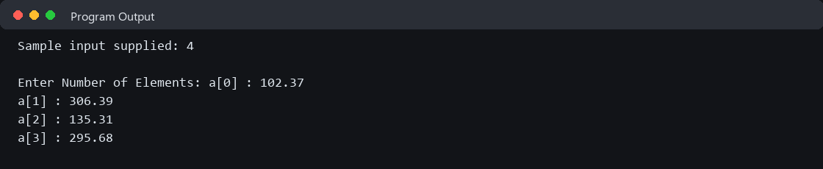
02. //A program to insert an integer into an array
// A program to Insert some Integer values in an Array

#include <stdio.h>
int main(){
int n = 10;
int arr[11] = {2,5,4,6,7,8,9,1,3,34};
int loc, item;

//taking input of location and item from user
printf("Enter Insert Location: ");
scanf("%d", &loc);

printf("Enter value to input: ");
scanf("%d", &item);

//shifting values to right
for(int i=n; i>loc; i--){
arr[i] = arr[i-1];
}

arr[loc] = item;

n = n+1;

//printing the final array with new item
for(int i=0; i<n; i++){
printf("%d ", arr[i]);
}

return 0;
}
Output:
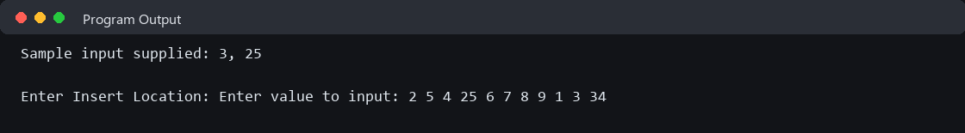
03. //A program to delete an integer from an array
// A program to delete an integer item from an array

#include <stdio.h>
int main(){

int arr[10] = {5,10,15,20,30,40,50,60,70,43};
int n= 10;
int loc;

printf("Enter location to delete the item: ");
scanf("%d", &loc);

for(int i=loc; i<n-1; i++){
arr[i] = arr[i+1];
}

n = n-1;

for(int i=0; i<n; i++){
printf("%d ", arr[i]);
}

return 0;
}
Output:
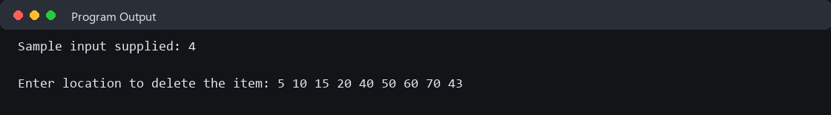
04. //A program to insert a string into an array

// A program to Insert a String in an Array

#include <stdio.h>
#include <string.h>

int main() {

int n = 10;

char arr[11][20] = {
"Apple", "Banana", "Mango", "Orange", "Grape",
"Guava", "Lemon", "Papaya", "Jackfruit", "Pineapple"
};

int loc;
char item[20];

printf("Enter Insert Location: ");
scanf("%d", &loc);

printf("Enter value to input: ");
scanf("%s", item);

// Shifting
for (int i = n; i > loc; i--) {
strcpy(arr[i], arr[i - 1]);
}

// Inserting
strcpy(arr[loc], item);

n++;

// Printing
for (int i = 0; i < n; i++) {
printf("%s ", arr[i]);
}

return 0;
}

// A program to Insert a String in an Array without srtcpy() method

// #include <stdio.h>
// #include<string.h>

// int main() {

// int n = 10;

// char arr[11][20] = {
// "Apple",
// "Banana",
// "Mango",
// "Orange",
// "Grape",
// "Guava",
// "Lemon",
// "Papaya",
// "Jackfruit",
// "Pineapple"
// };

// int loc;
// char item[20];

// // Taking input of location and item
// printf("Enter Insert Location: ");
// scanf("%d", &loc);

// printf("Enter value to input: ");
// scanf("%s", item);

// // Shifting values to right
// for (int i = n; i > loc; i--) {
// // Copy string
// int j = 0;

// while (arr[i - 1][j] != '\0') {
// arr[i][j] = arr[i - 1][j];
// j++;
// }

// arr[i][j] = '\0';
// }

// // Insert new string
// int j = 0;

// while (item[j] != '\0') {
// arr[loc][j] = item[j];
// j++;
// }

// arr[loc][j] = '\0';

// n = n + 1;

// // Printing final array
// for (int i = 0; i < n; i++) {
// printf("%s ", arr[i]);
// }

// return 0;
// }
Output:
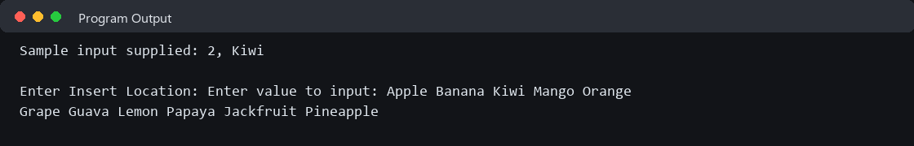
05. //A program to delete a string from an array

// A program to delete a string item from an array

#include <stdio.h>
#include<string.h>
int main(){

int n = 10;
int loc;

char str[10][20] = {
"Apple",
"Banana",
"Mango",
"Orange",
"Grape",
"Guava",
"Lemon",
"Papaya",
"Jackfruit",
"Pineapple"
};

printf("Enter Location to Delete item: ");
scanf("%d", &loc);

for(int i = loc; i < n-1; i++){
strcpy(str[i], str[i+1]);
}

n = n - 1;

for(int i = 0; i < n; i++){
printf("%s ", str[i]);
}

return 0;
}

// A program to delete a string item from an array without strcpy() method

// #include <stdio.h>

// int main(){

// char arr[10][20] = {
// "Apple",
// "Banana",
// "Mango",
// "Orange",
// "Grape",
// "Guava",
// "Lemon",
// "Papaya",
// "Jackfruit",
// "Pineapple"
// };

// int n = 10;
// int loc;

// printf("Enter location to delete the item: ");
// scanf("%d", &loc);

// // Shifting values to left
// for(int i = loc; i < n - 1; i++){

// int j = 0;

// while(arr[i + 1][j] != '\0'){
// arr[i][j] = arr[i + 1][j];
// j++;
// }

// arr[i][j] = '\0';
// }

// n = n - 1;

// // Printing final array
// for(int i = 0; i < n; i++){
// printf("%s ", arr[i]);
// }

// return 0;
// }
Output:
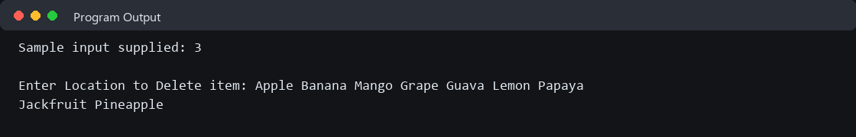
06. //A program to search an integer using linear search
//A program to search a value using lenear search

#include <stdio.h>
int main(){

int n=10;
int arr[10]={20,35,37,40,45,50,51,55,67,98};
int target;

printf("Enter target item to search: ");
scanf("%d", &target);

int flag = 0;

for(int i=0; i<n; i++){
if(arr[i] == target){
printf("Item found at index %d", i);
flag = 1;
break;
}
}

if(flag == 0){
printf("Item not found");
}

return 0;

}
Output:
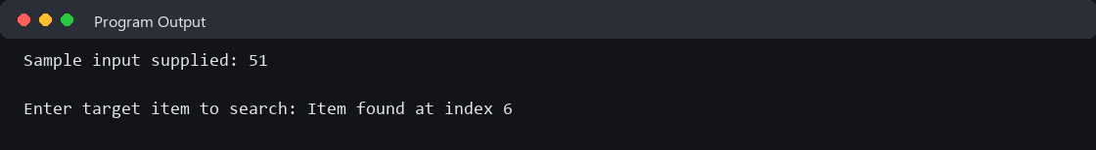
07. //A program to search an integer using binary search
//A program to search a given value using Binary Search

#include <stdio.h>
int main(){
int n=10;
int arr[10]={2,4,6,7,8,9,10,12,14,15};
int target = 9;
int flag = 0;

int beg = 0;
int end = n-1; // end = 9;

while(beg <= end){

int mid = (beg+end)/2;

if(arr[mid] == target){
printf("%d Found at index %d",target,mid);
flag = 1;
break;
}

else if(arr[mid] > target){
end = mid-1;
}

else beg = mid+1;
}

if(flag == 0){
printf("Target- %d Not found",target);
}

return 0;
}
Output:
08. //A program to search strings using linear search
// A program to lenear search a given value using string type data

#include <stdio.h>
#include<string.h>

int main(){

int i, loc, n, c;
char a[100][100], item[100];

printf("Enter Number of Elements: ");
scanf("%d", &n);

printf("Enter String: \n");

for(i=1; i<=n; i++){
printf("\n[%d]= ",i);
scanf("%s", a[i]);
}

while(1){

loc = -1;

printf("Enter Searching Item: ");
scanf("%s", item);

for(i=1; i<=n; i++){
if(strcmp(item, a[i]) == 0){
loc = i;
break;
}
}

if(loc == -1){
printf("\nAbsent");
}
else
printf("\nPresent at Location: %d", loc);

printf("\nEnter 1 for search again, any number for exit: \n");
scanf("%d", &c);

if(c != 1){
return 0;
}

}

return 0;

}
Output:
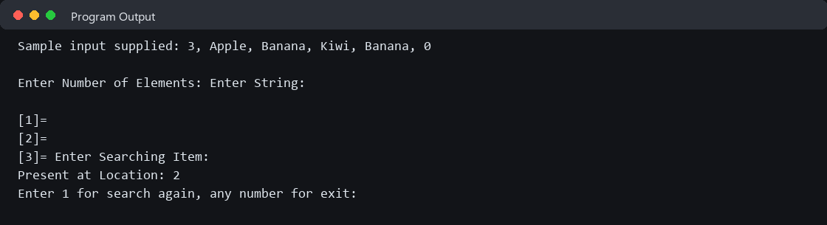
09. //A program to sort integers using bubble sort
// A program to sort some Integer values using Bubble Sort

#include <stdio.h>
#include<stdlib.h>
#include<time.h>

int main(){
int a[50];
int n,temp;

printf("Enter Number of elements :");
scanf("%d", &n);

srand(time(NULL));
for(int i=0; i<n; i++){
a[i] = rand()/100;
printf("%d\n", a[i]);
}

for(int j=1; j<=n-1; j++){
printf("\nPass %d:\n", j);

for(int i=0;i<n-j; i++ ){
if(a[i]>a[i+1]){
temp = a[i];
a[i] = a[i+1];
a[i+1] = temp;
}
for(int k=0;k<n; k++){
printf("%5d",a[k]);
}
printf("\n");

}
}

printf("\n\nSorted list :");
for(int i=0; i<n; i++){
printf("\na[%d] = %d", i,a[i]);

}
return 0;
}
Output:
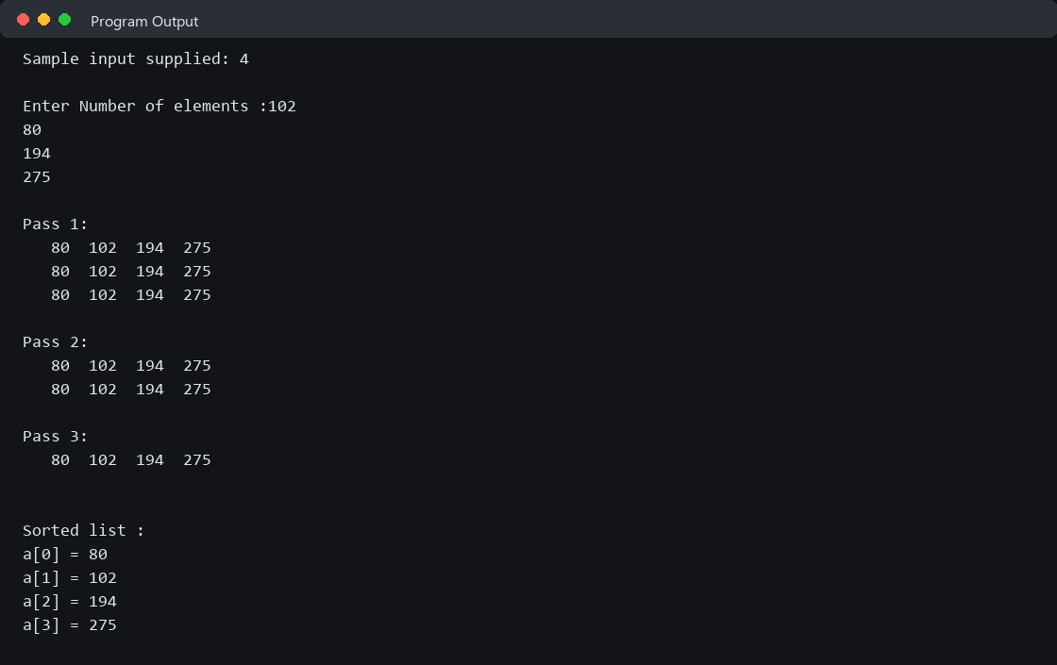
10. //A program to sort strings using bubble sort
// A program to sort 10 string values using Bubble Sort

#include <stdio.h>
#include <string.h>

int main(){

char a[10][20] = {
"Mango",
"Apple",
"Orange",
"Banana",
"Grape",
"Lemon",
"Guava",
"Papaya",
"Jackfruit",
"Pineapple"
};

int n = 10;
char temp[20];

// Bubble Sort
for(int j = 1; j <= n - 1; j++){

printf("\nPass %d:\n", j);

for(int i = 0; i < n - j; i++){

if(strcmp(a[i], a[i + 1]) > 0){

strcpy(temp, a[i]);
strcpy(a[i], a[i + 1]);
strcpy(a[i + 1], temp);
}

// Printing array after each comparison
for(int k = 0; k < n; k++){
printf("%15s", a[k]);
}

printf("\n");
}
}

printf("\n\nSorted list:");

for(int i = 0; i < n; i++){
printf("\na[%d] = %s", i, a[i]);
}

return 0;
}
Output:
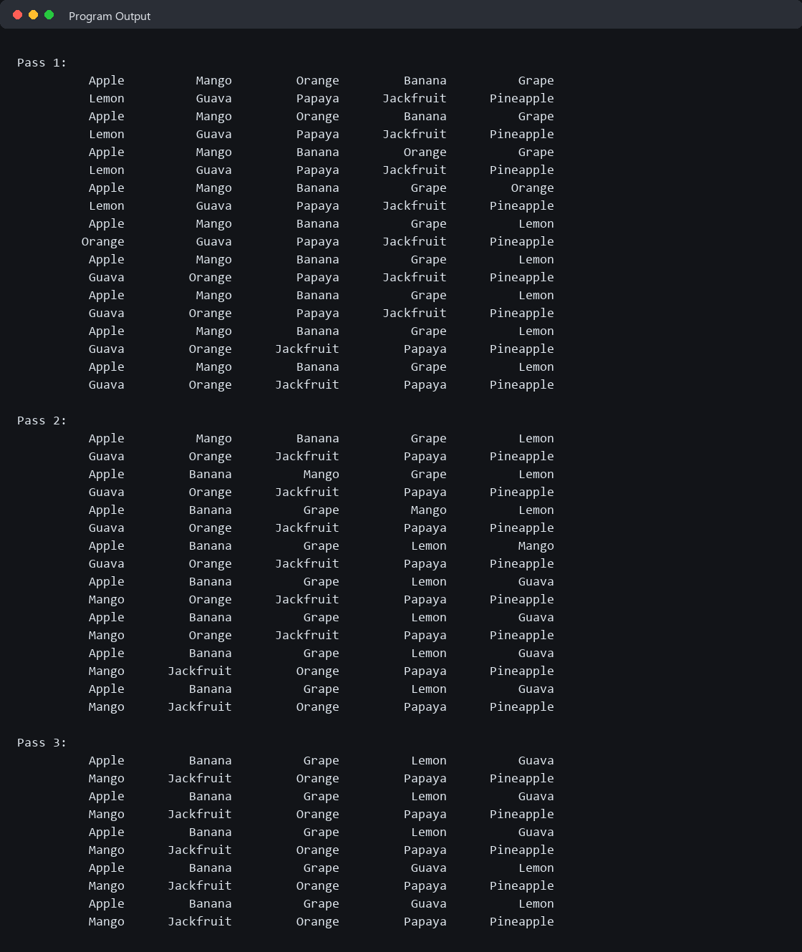
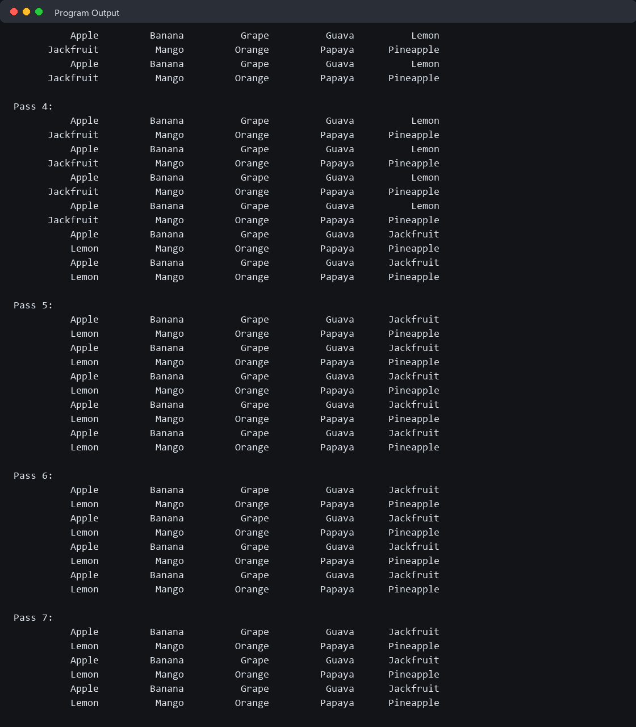
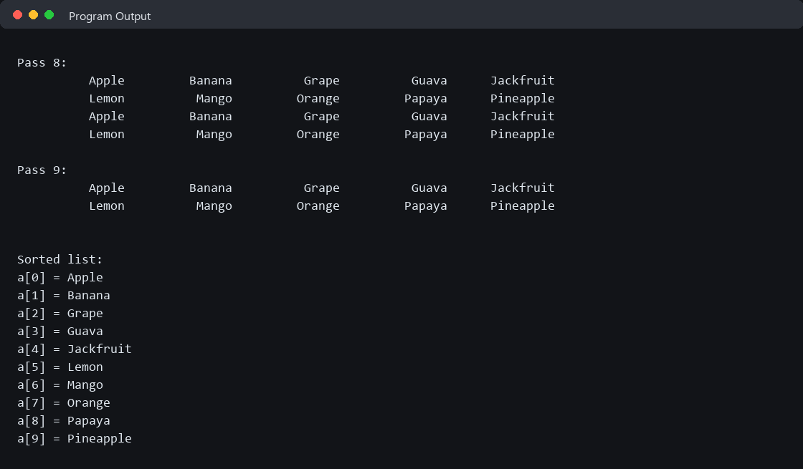
11. //A program to implement push and pop operations using a stack
//A program to Implementation of Push and Pop operations using Stack

#include<stdio.h>

int stk[20], i, mx = 5, top= -1, item, c;

int pop(){
if(top == -1){
printf("Stack is empty/underflow");
return 0;
}

item = stk[top];
top = top - 1;

printf("\nPopped item = %d", item);
printf("\nSTACK: \n");

for(i = top; i>=0; i--){
printf("\nstack[%d]= %d", i, stk[i]);
}

return 0;
}

int push(){
if(top == mx-1){
printf("\nStack is full/overflow");
return 0;
}

top = top+1;
printf("\nEnter new item to push: ");
scanf("%d", &item);
stk[top] = item;
printf("\nSTACK: \n");

for(i=top; i>=0; i--){
printf("\nstack[%d]= %d", i, stk[i]);
}

return 0;
}

int main(){
for( ; ; ){
printf("\nEnter your choice:\n 1. PUSH\n 2. POP\n 3. EXIT\n");
scanf("%d", &c);

switch(c){
case 1: push();
break;

case 2: pop();
break;

default:
return 0;
}
}

return 0;
}
Output:
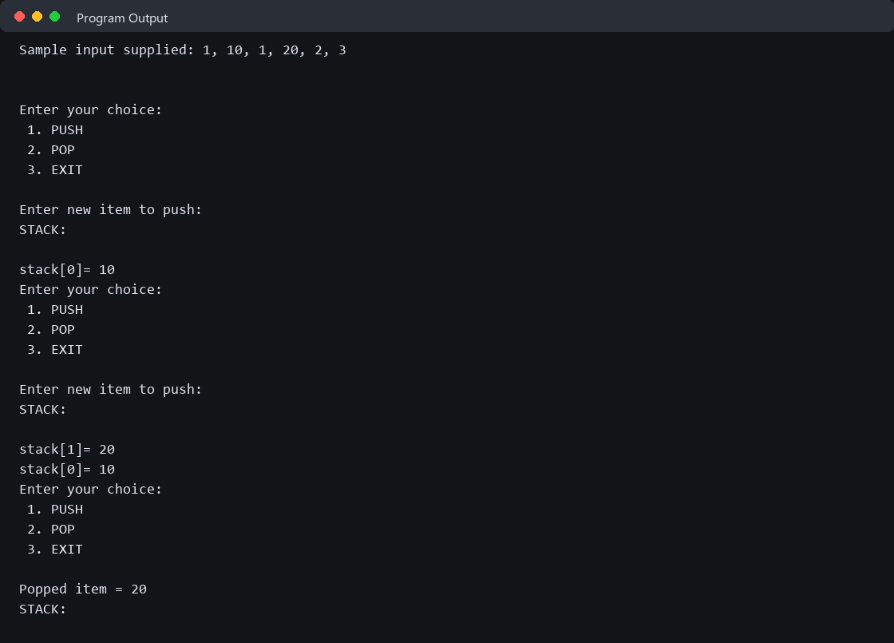
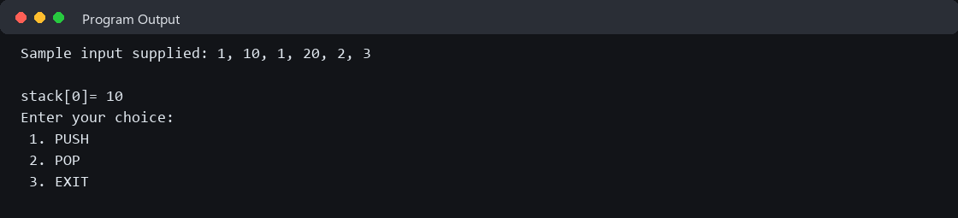
12. //A program to perform enqueue and dequeue operations on a queue

#include <stdio.h>

int queue[20], n = 5;
int front = -1, rear = -1;

void enqueue(int x)
{
if(rear == n-1)
{
printf("Queue is full");
return;
}

else if(front == -1 && rear == -1)
{
front = rear = 0;
queue[rear] = x;
}

else{
rear++;
queue[rear] = x;
}

for(int i = front; i<=rear; i++){
printf("queue[%d]= %d\n", i, queue[i]);
}
}

void dequeue()
{
if(front == -1 && rear == -1)
{
printf("Queue is empty");
return;
}

else if(front == rear)
{
printf("Deleted item = %d\n", queue[front]);
front = -1;
rear = -1;
}
else
{
printf("Deleted item = %d\n", queue[front]);

front++;
}

if(front != -1)
{
for(int i = front; i <= rear; i++){
printf("queue[%d] = %d\n", i, queue[i]);
}
}
}

int main()
{
int choice, x;

while(1)
{
printf("\n\n1. Enqueue");
printf("\n2. Dequeue");
printf("\n3. Exit");
printf("\nEnter choice: ");
scanf("%d", &choice);

switch(choice)
{
case 1:
printf("Enter item: ");
scanf("%d", &x);
enqueue(x);
break;

case 2:
dequeue();
break;

case 3:
return 0;

default:
printf("Invalid choice");
}
}

return 0;
}
Output:
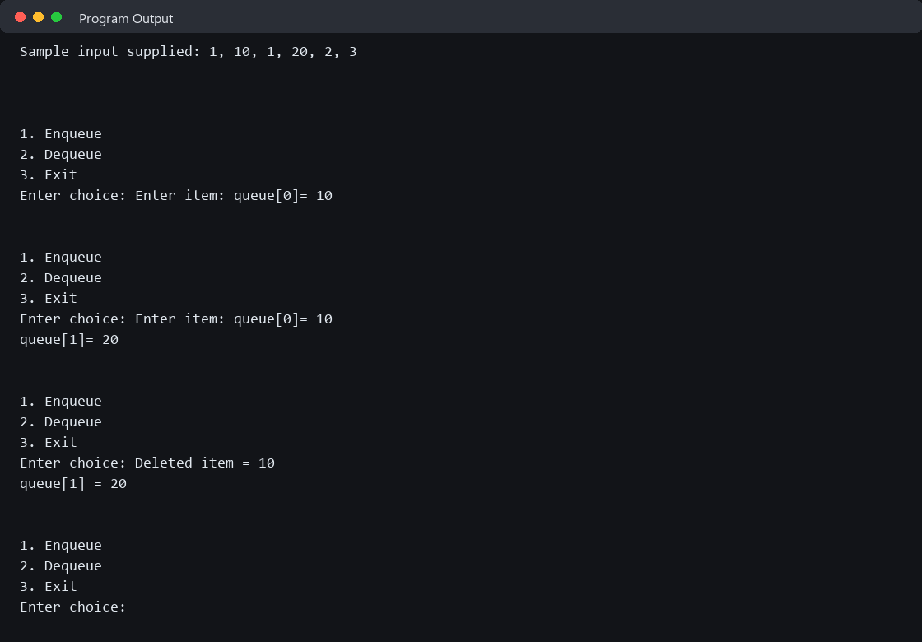
13. //A program to create and display a linked list
#include <stdio.h>
#include <stdlib.h>

// 1. Define the structure of a node
struct Node {
int data;
struct Node* next;
};

int main() {
int n, i, value;
struct Node *head = NULL, *temp = NULL, *newNode = NULL;

printf("Enter the number of elements (n): ");
scanf("%d", &n);

if (n <= 0) {
printf("List size must be greater than 0.\n");
return 0;
}

// 2. Loop to create 'n' elements dynamically
for (i = 1; i <= n; i++) {
printf("Enter data for element %d: ", i);
scanf("%d", &value);

// Allocate memory for the new node
newNode = (struct Node*)malloc(sizeof(struct Node));
newNode->data = value;
newNode->next = NULL;

if (head == NULL) {
// If the list is empty, make this the first (head) node
head = newNode;
temp = head;
} else {
// Otherwise, link the previous node to this new node
temp->next = newNode;
temp = newNode; // Move the temp tracker to the new end node
}
}

// 3. Traverse and display the linked list
printf("\nCreated Linked List: ");
temp = head;
while (temp != NULL) {
printf("%d -> ", temp->data);
temp = temp->next;
}
printf("NULL\n");

// 4. Free allocated memory (Good practice)
temp = head;
while (temp != NULL) {
struct Node* nextNode = temp->next;
free(temp);
temp = nextNode;
}

return 0;
}
Output:


